CS 255 System Design Document Template

UML Diagrams

UML Use Case Diagram
Actors (Customer, Secretary, Driver, Owner, IT Officer, and the DMV as an outside system) and the tasks each can perform. The generalized User actor stands for everyone who must Log In. «include» arrows show steps that always happen inside a task (assigning a driver and car, checking availability, and logging each reservation change); «extend» shows Reset Password as an optional path from Log In.
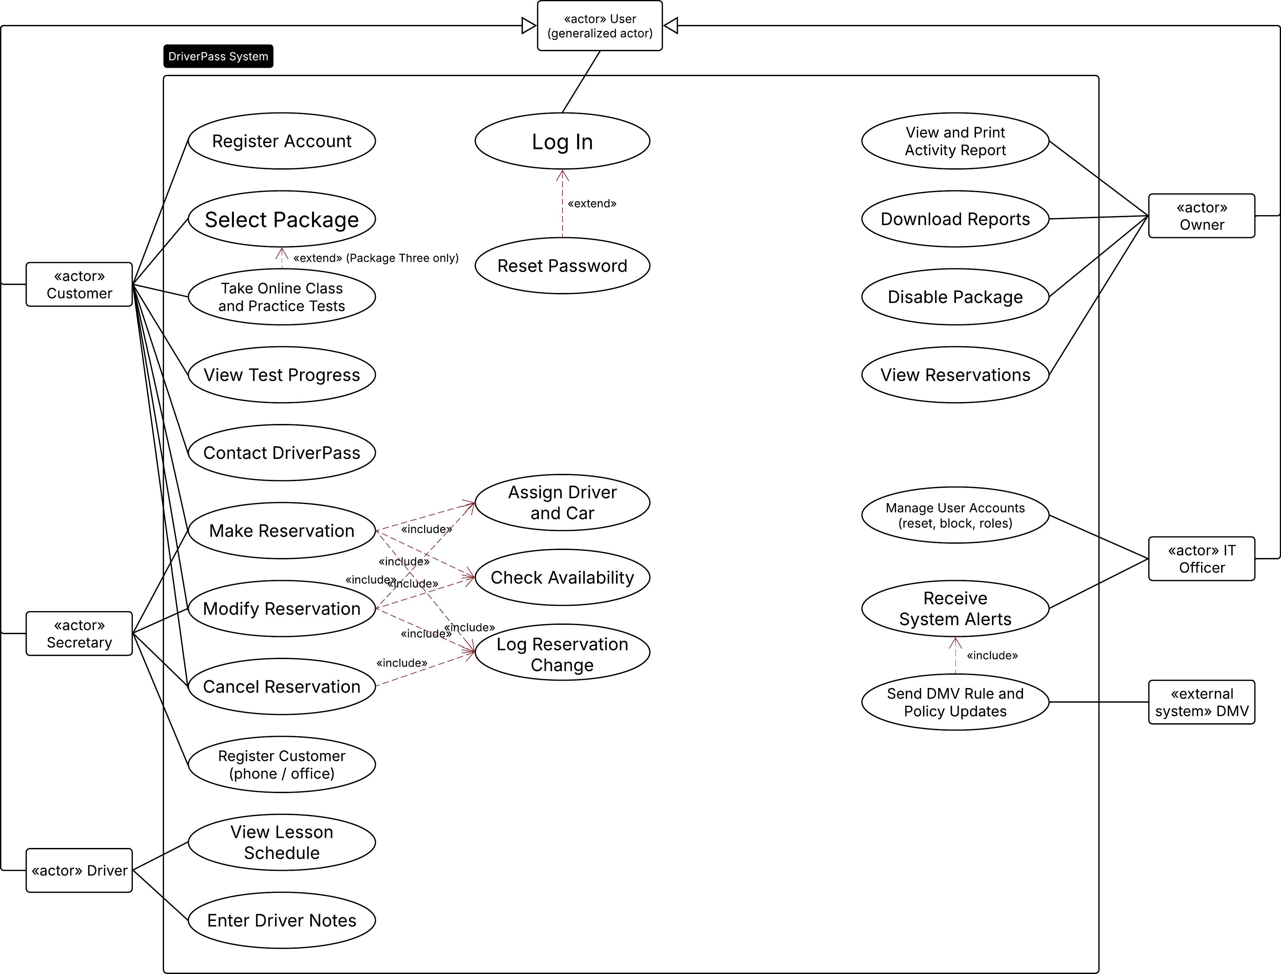

UML Activity Diagrams
Activity Diagram 1: Make a Reservation
Swimlanes separate the customer (or the secretary acting for the customer) from the system. The decision points are the login check (a fifth failed attempt locks the account and alerts the IT officer, an extra lane) and the driver-and-car availability check that prevents double-booking.
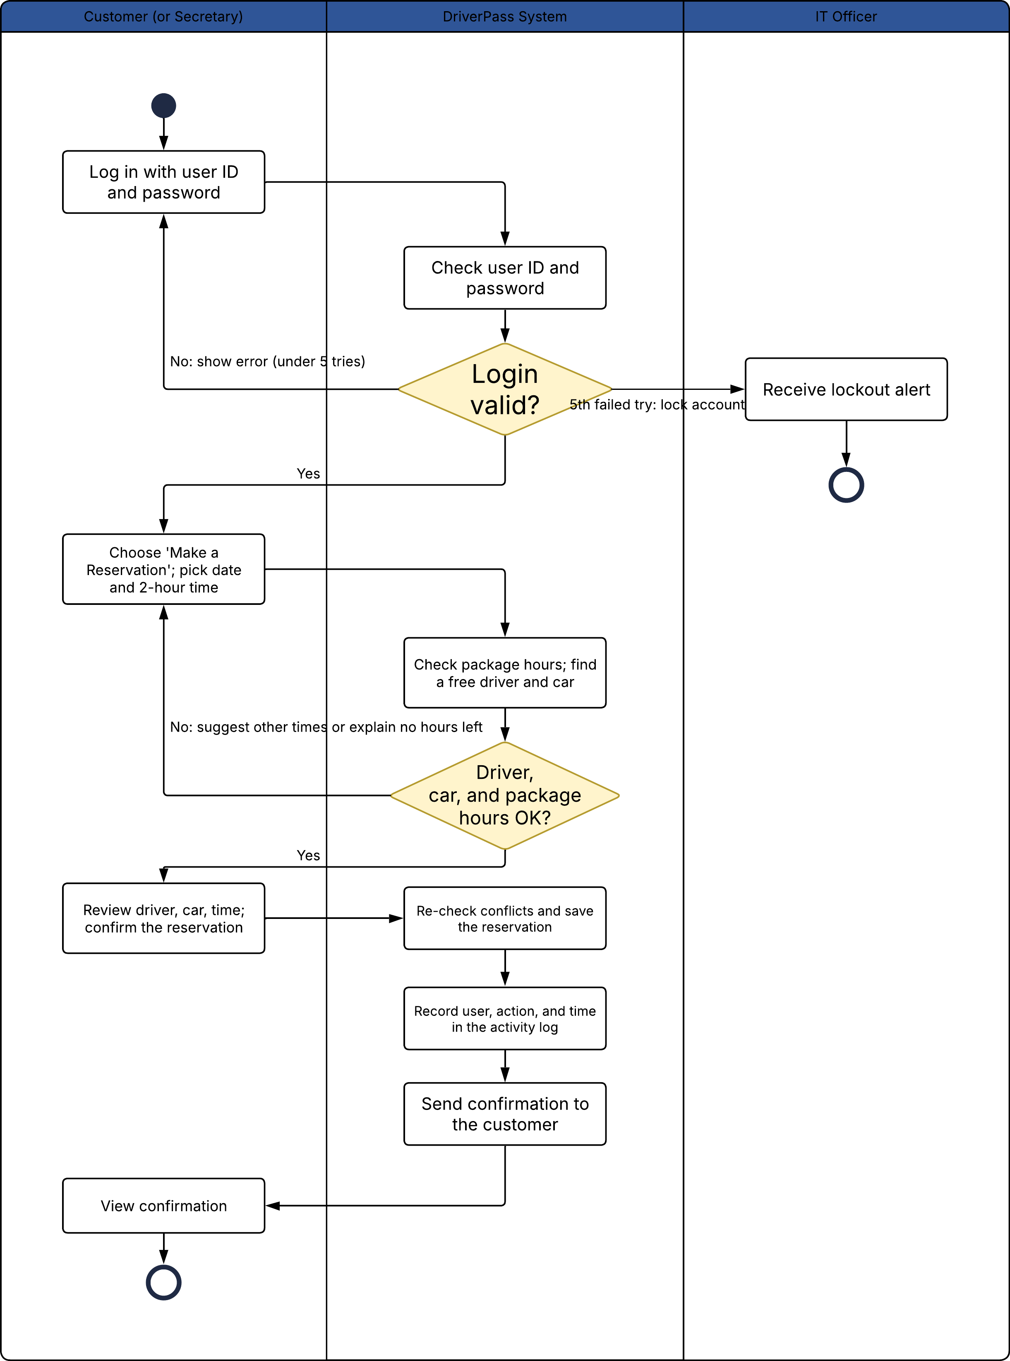
Activity Diagram 2: Reset Password (customer self-service)
A forgotten password is reset through a secure, time-limited email link with no staff help. The system gives the same message whether or not an account is found, so the screen does not reveal which user IDs exist.
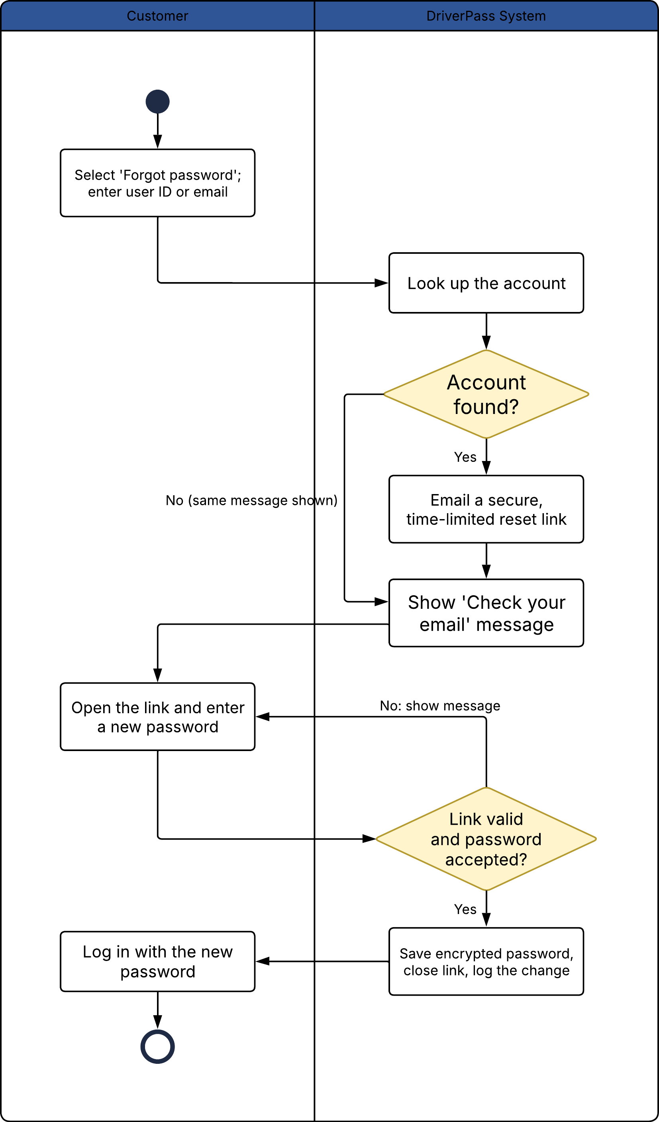

UML Sequence Diagram
Sequence for the Make a Reservation use case. Messages are numbered in order. The alt frame shows the two outcomes: a driver and car are available (steps 8 to 16), or none are (steps 17 and 18). Reservation and ActivityLog are classes from the class diagram, Reservation Page is the user interface, and Database and Email Service are outside components. Step 11 re-checks for a conflict at save time so two people cannot book the same slot at the same moment.
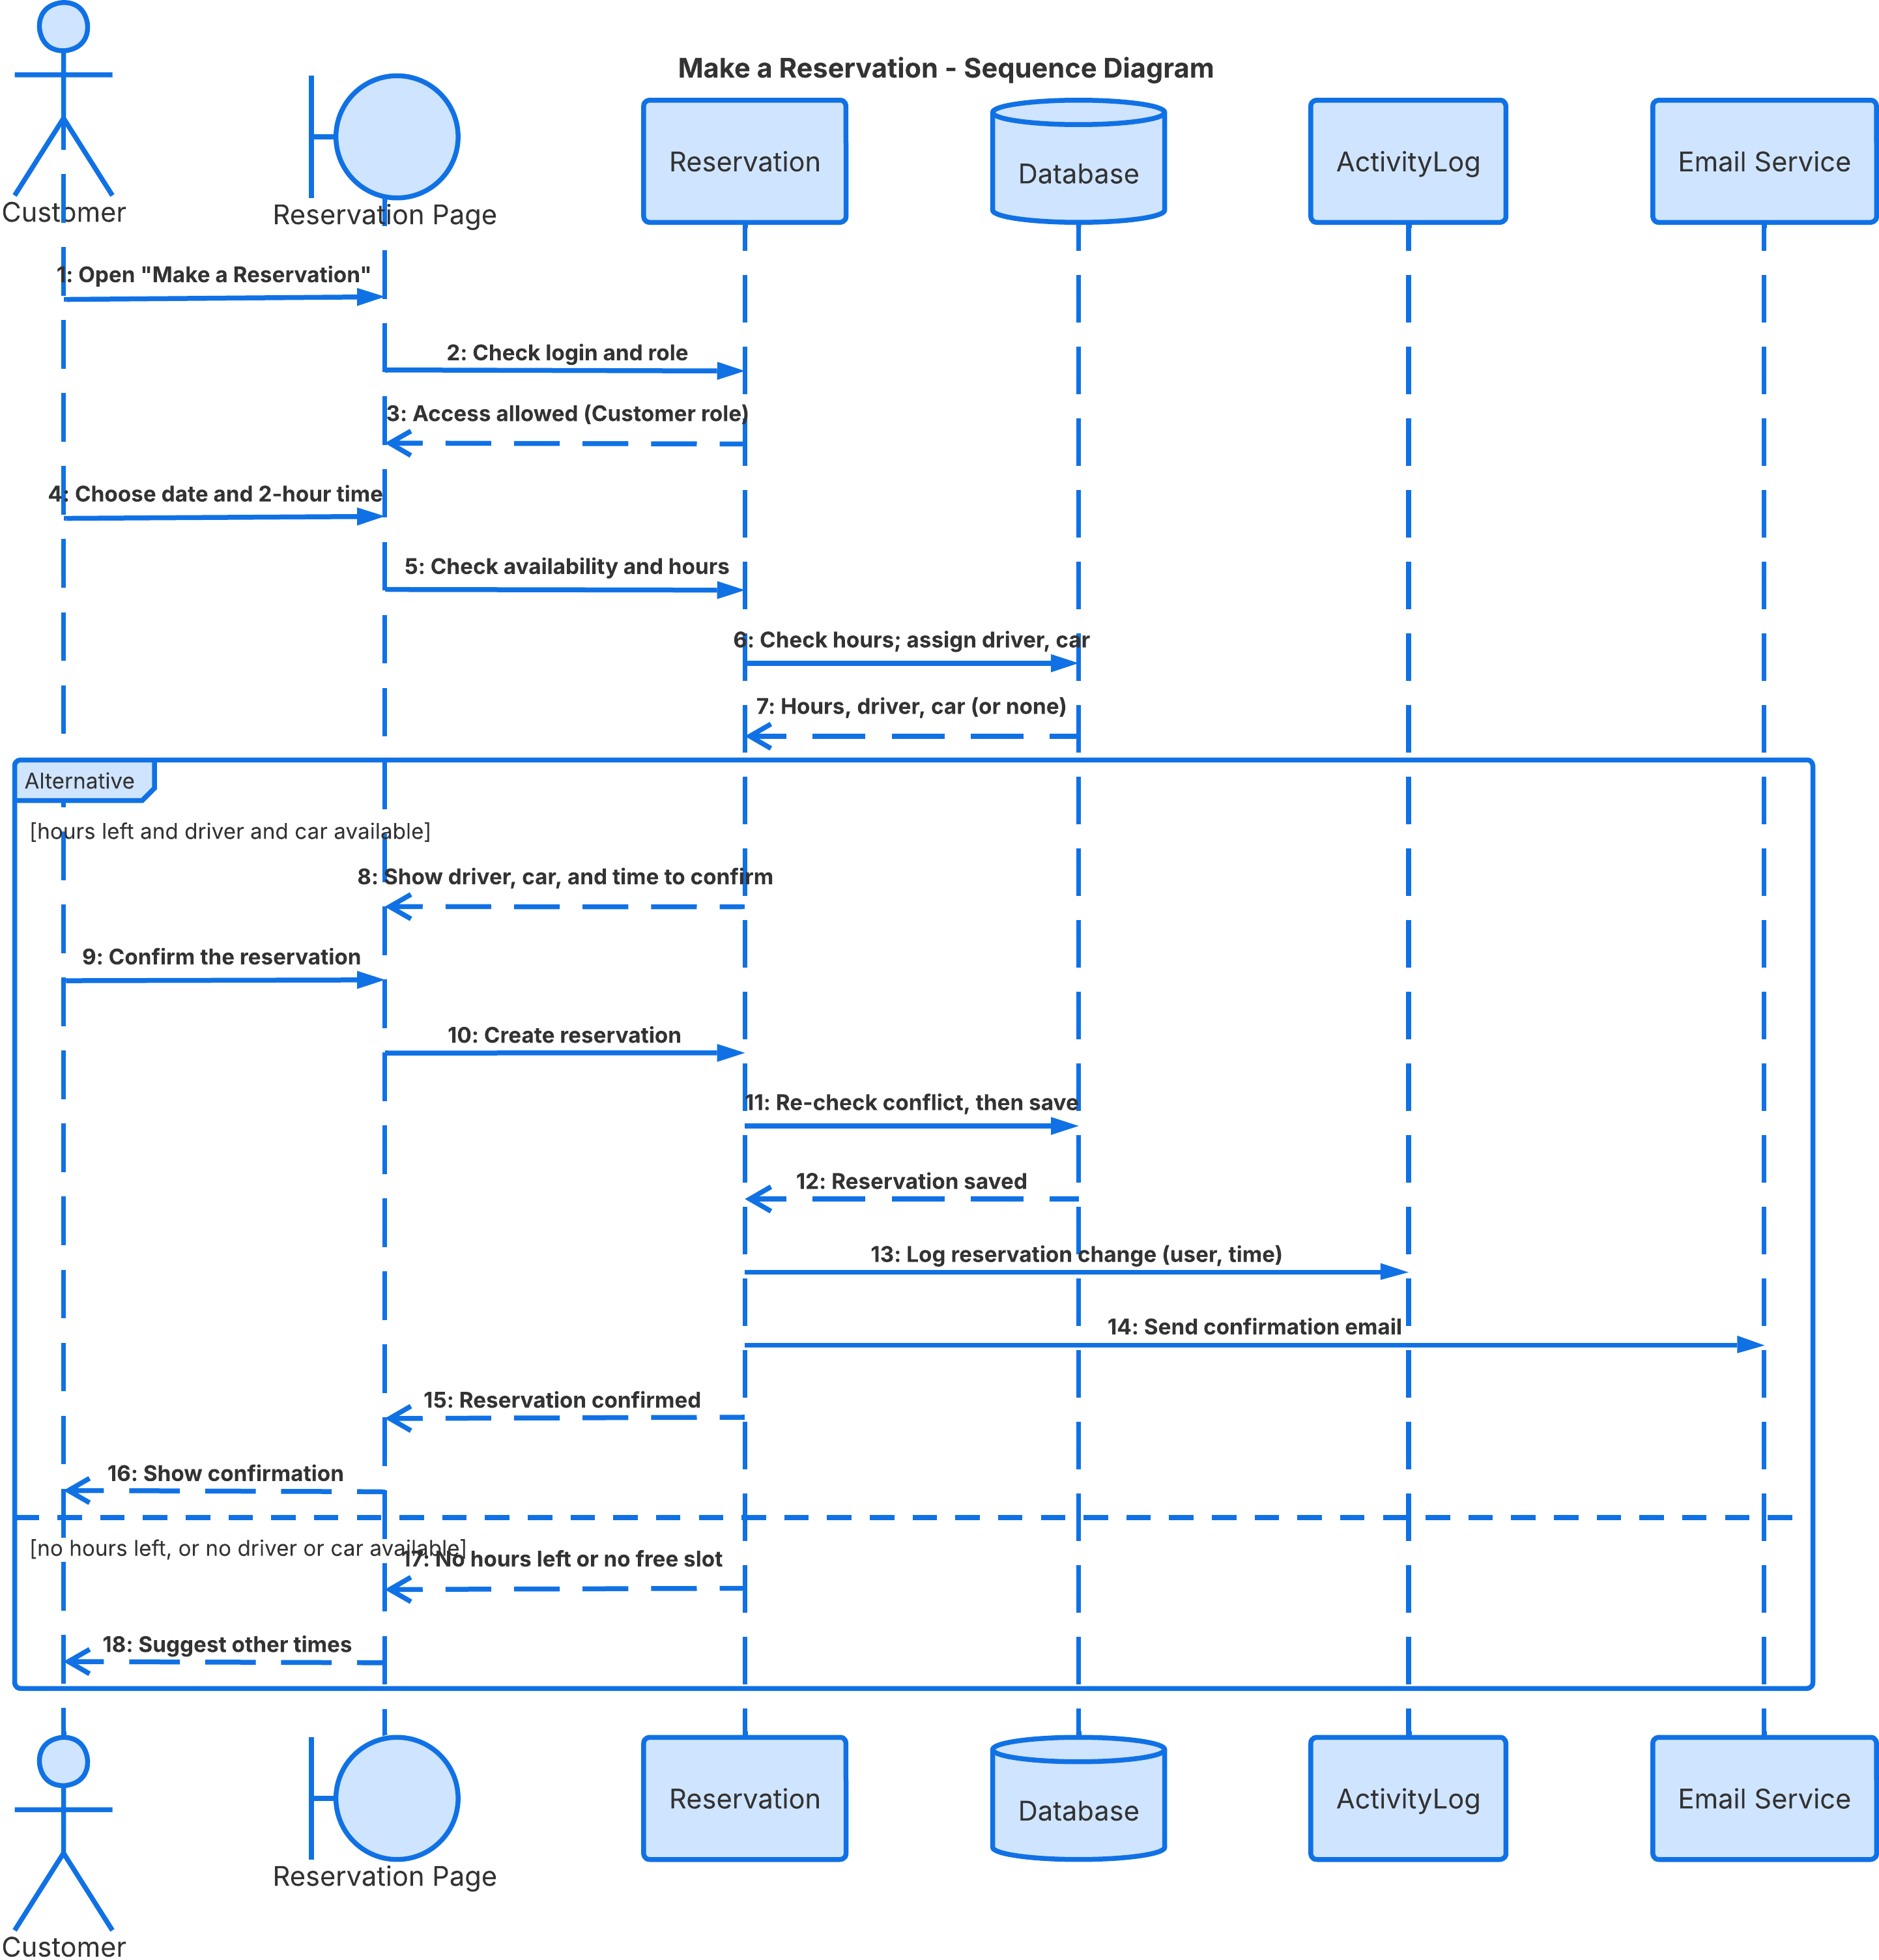

UML Class Diagram
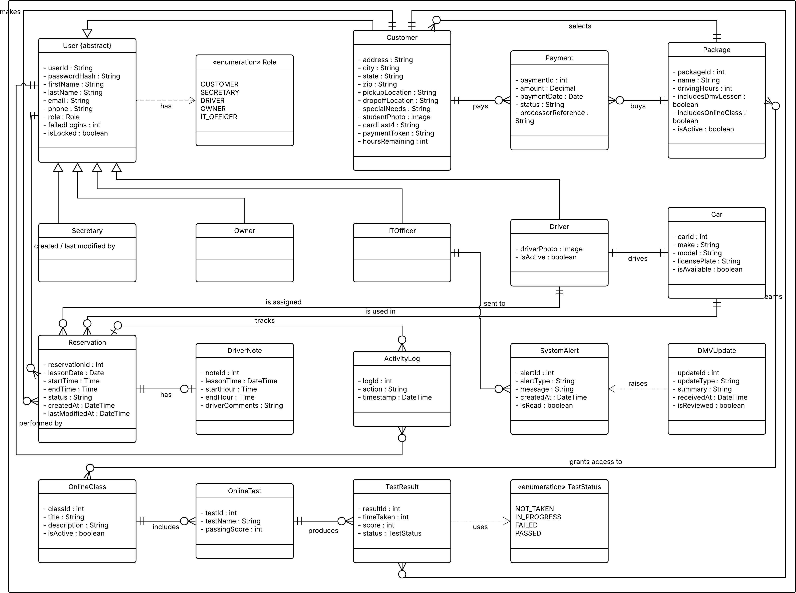

Technical Requirements
These requirements follow from the diagrams above and from the functional and nonfunctional requirements in the Business Requirements Document. DriverPass has no existing system and wants hosting, backup, and security handled for it, so the design is a cloud-hosted web application with nothing for customers to install. Product names are recommendations for the development team to confirm.

Hardware
- Customer devices: Any desktop, laptop, tablet, or smartphone with an internet connection and a current browser. No special hardware is needed.
- DriverPass office: A computer for the secretary (registering customers by phone and managing reservations), and computers or mobile devices for the owner and IT officer. The owner needs a printer or PDF printing for activity reports. Drivers use a smartphone or tablet to see schedules and enter lesson notes.
- Servers: None on site. The application runs on virtual servers or managed services from a cloud provider. Start with at least two application instances behind a load balancer for reliability and add capacity as needed; the user base is small (10 cars and drivers).
- Storage: Managed database storage plus object (file) storage for customer and driver photos, exported reports, and backups.

Software
- Front end: A responsive web application (HTML5, CSS, and JavaScript, for example with React) that works in current Chrome, Edge, Safari, and Firefox on Windows, macOS, iOS, and Android, following the owner's interface sketch.
- Back end: A web application server exposing the Reservation, Package, User, Test, and Report services (for example Java with Spring Boot, ASP.NET Core, or Node.js). It implements the classes in the class diagram and checks the user's role on every request.
- Database: A relational database (for example PostgreSQL or MySQL) holding users, customers, packages, reservations, drivers, cars, driver notes, tests and results, DMV updates, and the activity log. Transactions and uniqueness rules on driver, car, customer, and time slot prevent double-booking.
- Security components: Password hashing (bcrypt or Argon2), role-based access control, session timeout, account lockout, and TLS (HTTPS) for all traffic.
- Payment processing: A third-party, PCI DSS-compliant payment processor handles card payments. As the BRD requires, stored card information is encrypted and shown only in part (last four digits). The security code is used only to authorize payment and should not be kept afterward (PCI DSS practice; to confirm with the processor).
- Email service: A transactional email provider for reservation confirmations and password-reset links.
- DMV interface: An integration module that receives rule, policy, and sample-question updates (secure API, file feed, or email, to be confirmed with the DMV), saves them as DMV updates, and alerts the IT officer. A failed update raises an alert.
- Reporting: A report service that produces a printable activity report (who created, canceled, or last modified each reservation) and CSV or XLSX downloads that Excel can open.
- Online class and practice tests: A module that serves class content and practice tests and records time taken, score, and status (not taken, in progress, failed, passed).
- Operating system: Linux servers managed by the cloud provider. Users are unaffected by platform.

Tools
- Design and planning: Lucidchart for UML diagrams and the Gantt chart.
- Development: Git for version control, an issue tracker, and an IDE of the team's choice.
- Testing: Automated unit and integration tests, browser and mobile device testing, load testing against the 3-second response target, and security scanning of code and libraries.
- Operations: Automated build and deployment (CI/CD), plus logging and monitoring that send alerts to the IT officer for repeated failed logins, system or database errors, failed DMV updates, failed backups, and scheduling conflicts.

Infrastructure
- Cloud hosting: A major cloud provider (AWS, Microsoft Azure, or Google Cloud) with managed hosting, a managed database, a load balancer, and DNS.
- Backup and recovery: Automated daily backups with point-in-time recovery, handled by the provider, with alerts if a backup fails.
- Security: HTTPS only, a firewall (web application firewall recommended), and encryption at rest for the database and stored files.
- Environments: Separate development, test, and production environments so testing never affects live reservations.
- Maintenance: Routine updates scheduled outside business hours. DMV updates are received as soon as the DMV sends them. The system is retested after major browser or provider updates.
- Targets (proposed, pending DriverPass approval): Pages and reservation actions respond within about 3 seconds under normal load, availability of at least 99%, and a reservation completed in under 3 minutes.

How the Design Meets the Requirements
Requirement | Technical response
Use from any computer or phone | Responsive web app in major browsers; no install; HTTPS.
No double-booking; real-time updates | Database transaction and unique constraints on driver, car, customer, and time slot; conflict re-check at save (sequence step 11).
Log who created, canceled, or changed a reservation | Reservation Service writes an ActivityLog entry (user, action, time) in the same transaction; report service prints it.
Role-based access for five roles | User superclass with role subclasses; role checked on every request.
Password reset, lockout, and blocking | Hashed passwords, time-limited emailed reset link, lockout after 5 failed logins (proposed), IT officer screen to reset or block any account.
Protect credit card data | PCI DSS-compliant payment processor, encryption of stored card data, only the last four digits shown, HTTPS in transit.
Enforce package hours | Customer.hoursRemaining is checked at booking (activity step and sequence step 5 to 7). How cancellations affect hours is a DriverPass policy still to be defined.
Stay current with DMV changes | DMV integration module, DMVUpdate records, and alerts to the IT officer.
Reports to Excel and print | Export service (CSV or XLSX) and print-friendly report page.
View offline, change only online | Downloaded reports for offline use; the application disables changes when there is no connection.
Speed and availability | Load balancer, two or more instances, managed database, monitoring, and load testing before launch.

